**CAPSTONE PROJECT**

**Covid-19 Forecasting Using Prophet**

**SUBMITTED BY**

**PADMANABAN S**

**Table of Contents**

1. Problem Statement

2. Project Objective

3. Data Description

4. Data Pre-processing Steps and Inspiration

5 EDA

6. Choosing the Algorithm for the Project

7. Model Evaluation and Techniques

8. Conclusion

9. References

**1 Problem Statement**

Given data about COVID-19 patients, write code to visualize the impact and analyze the trend of rate of infection and recovery as well as make predictions about the number of cases expected a week in future based on the current trends.

**2 Project Objective**

● Use pandas to accumulate data from multiple data files.

● Use plotly (visualization library) to create interactive visualizations.

● Use Facebook prophet library to make time series models.

● Visualize the prediction by combining these technologies.

**3 Data Description**

CSV and Excel files containing data about the number of COVID-19 confirmed deaths and recovered patients both around the world and in India.

Loading Dataset

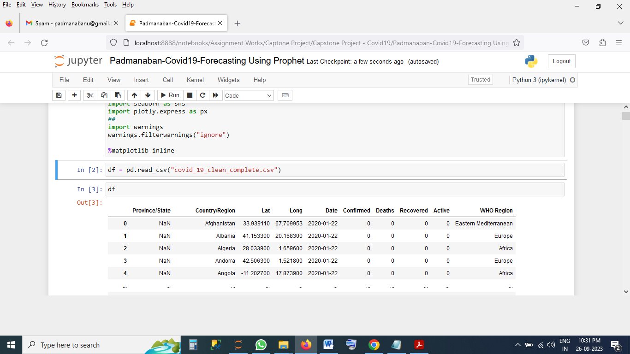

Dataset Info

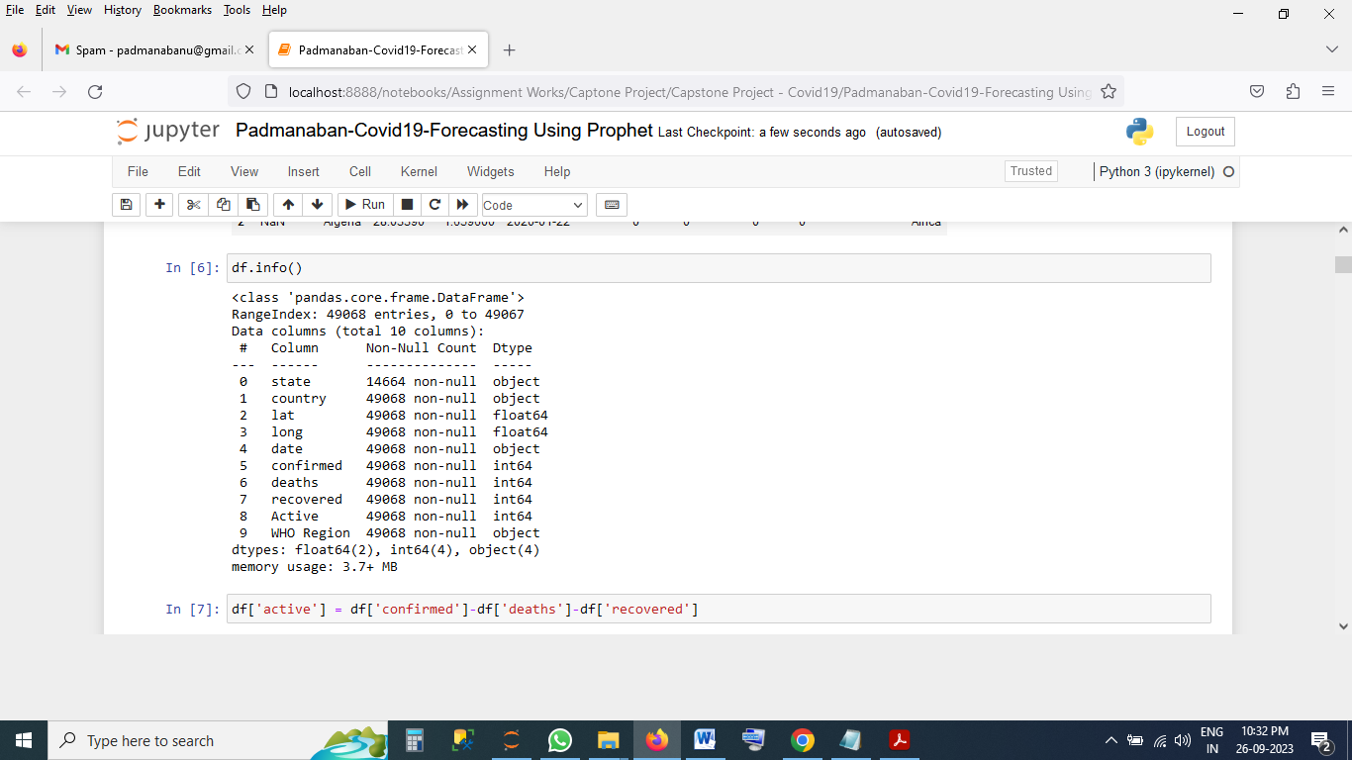

**4. Data Pre-processing Steps and Inspiration**

Change Column Name as Easy to Access

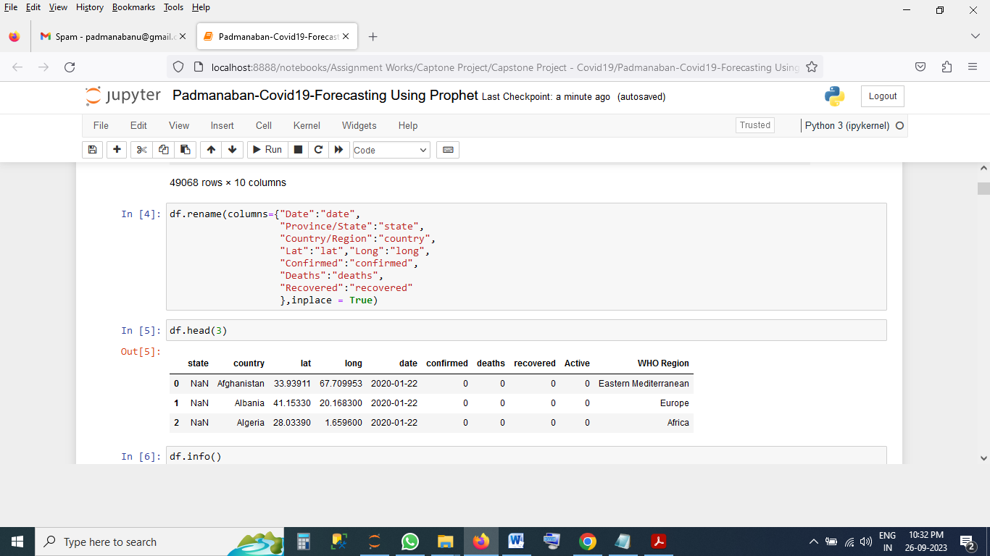

Check Active Cases Are Correct

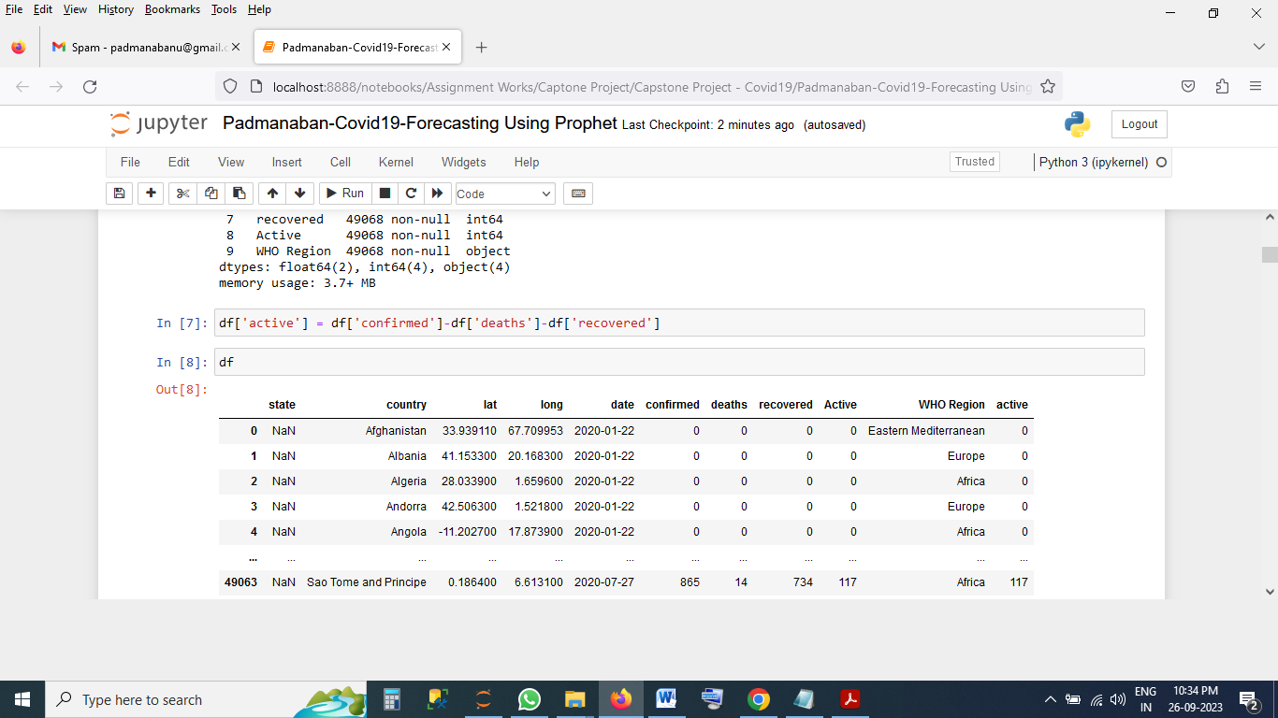

**5 EDA Results**

EDA To Check Maximum Case 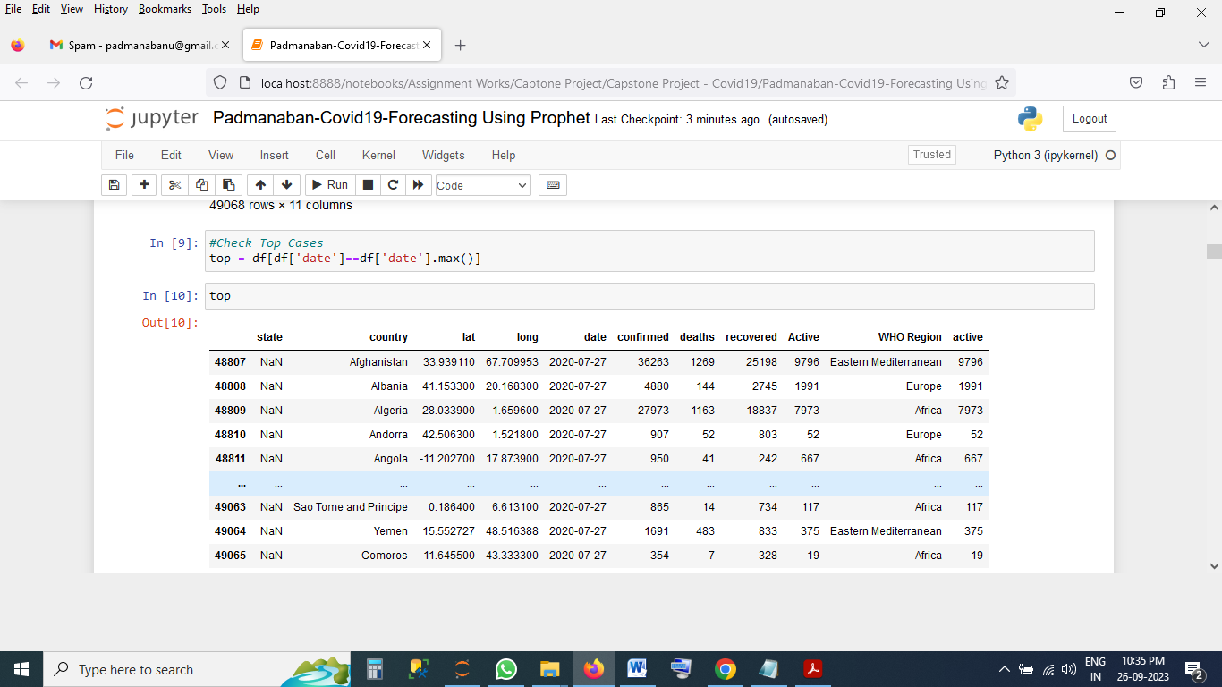

**Country wise Case List**

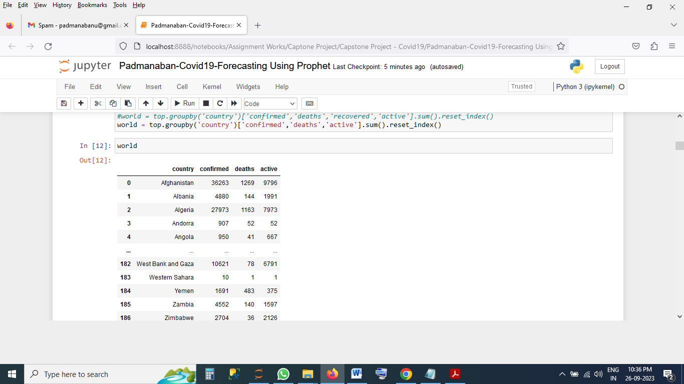

**Country Wise Case Using choropleth Plotly Visualization**

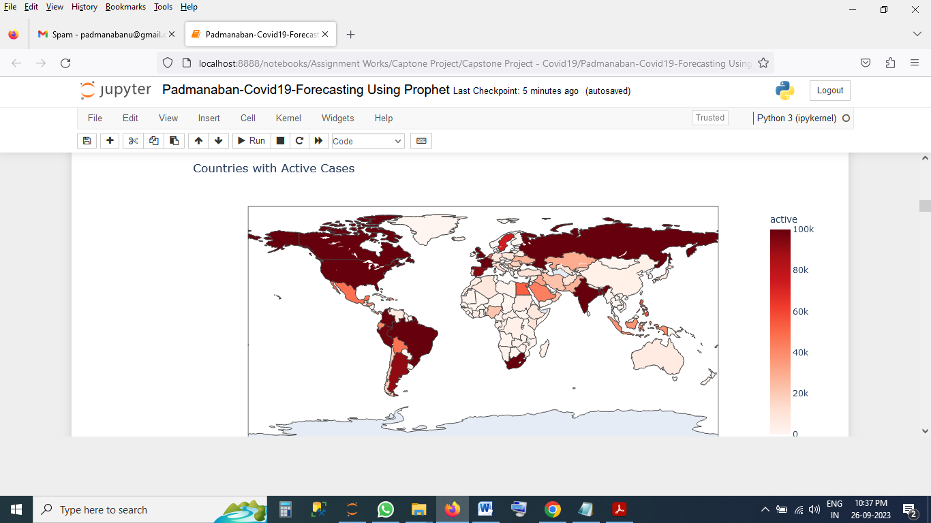

**Covid Trend on World Wise**

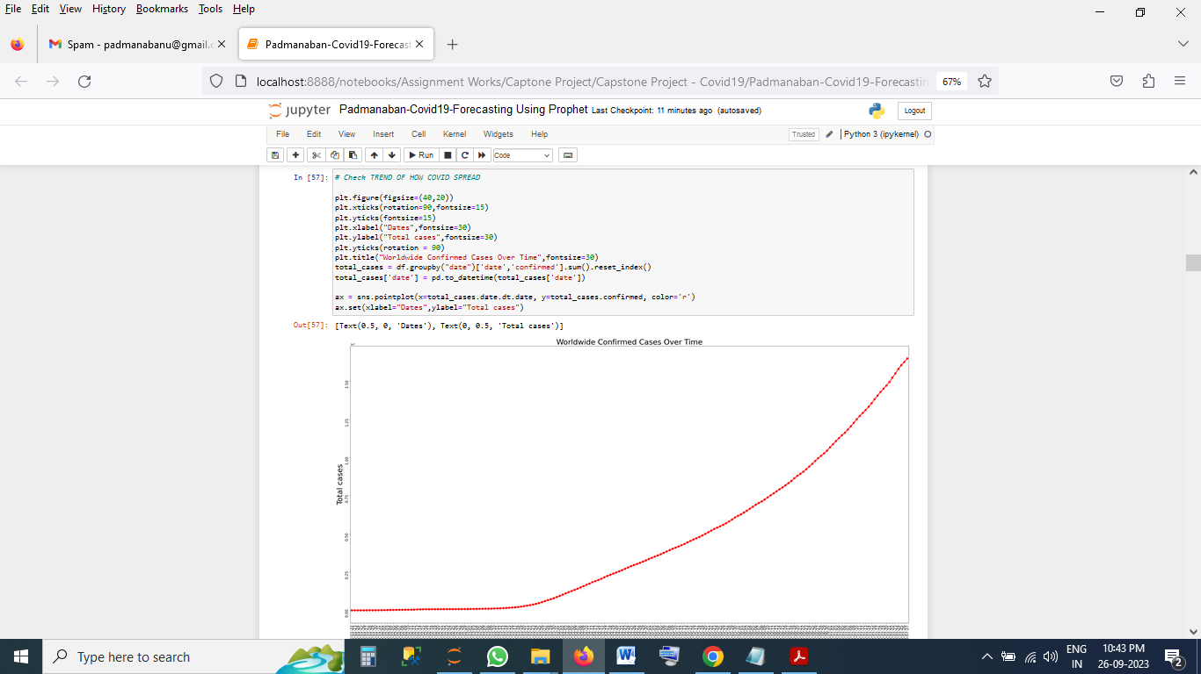

Most Active Case in top 20 Country

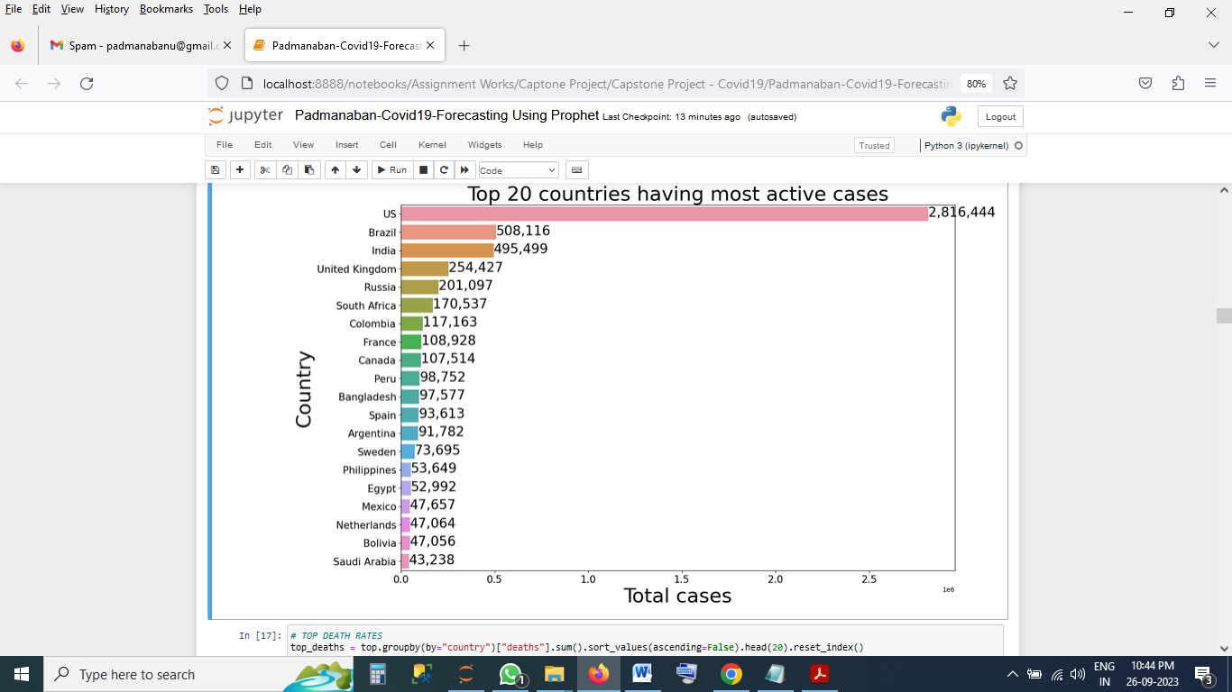

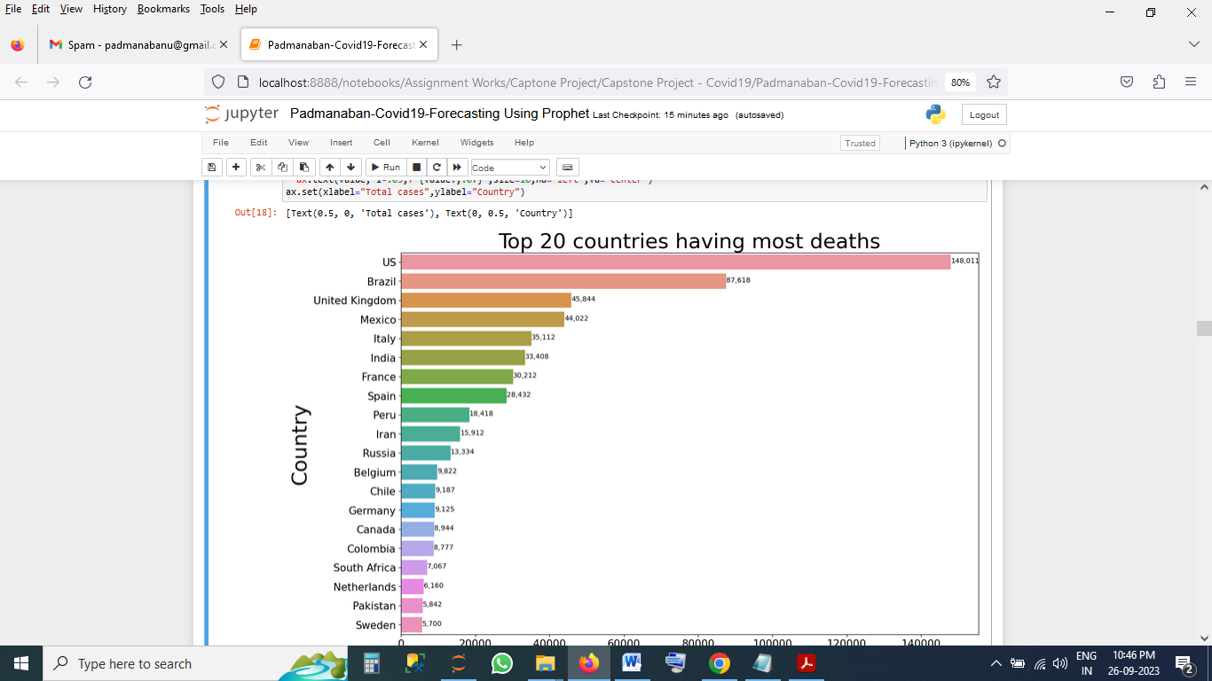

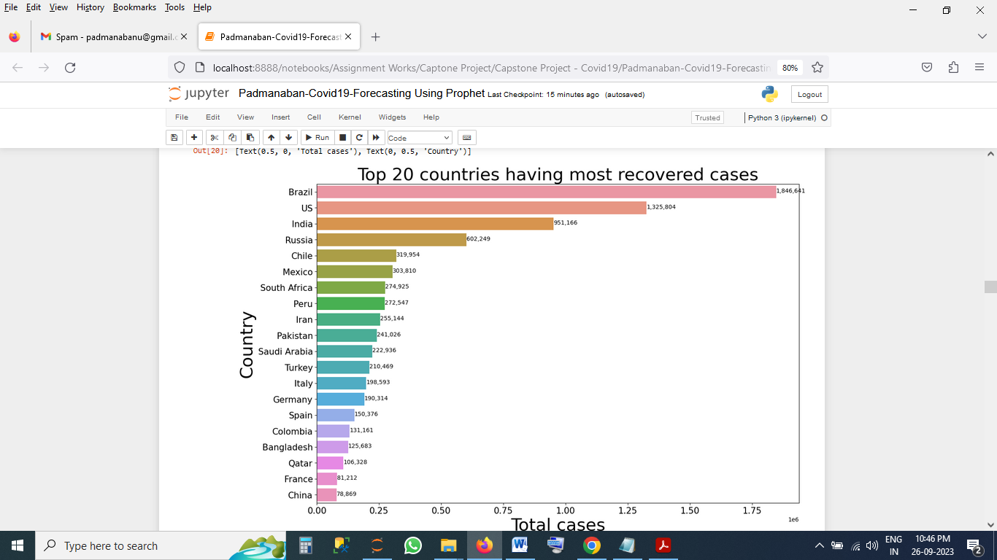

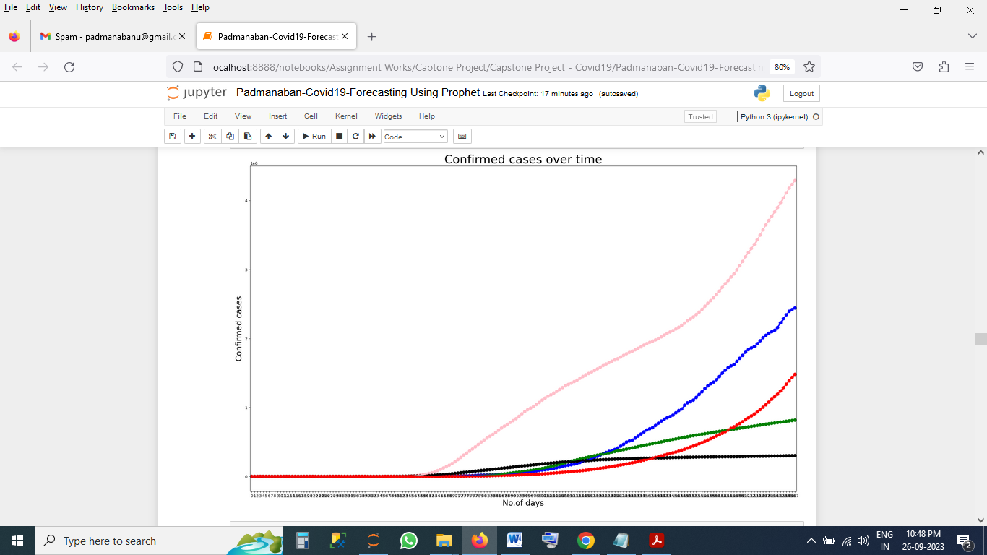

**6. Choosing the Algorithm for the Project**

I am Here using Prophet Library For Forecasting

#Forecast Model

#pip install prophet

#pip show prophet

from prophet import Prophet

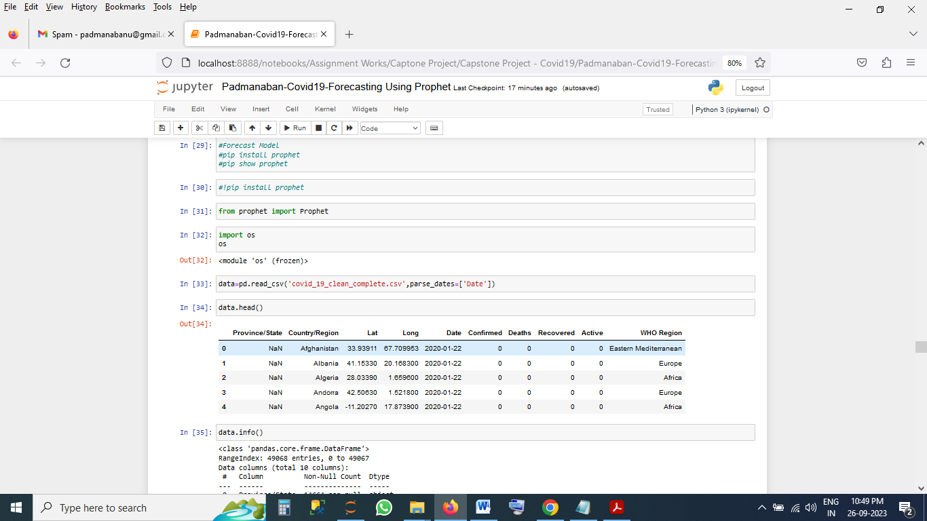

#change column name for prophet library require

# ds = datatime

#y target value

confirmed.columns = ['ds','y']

confirmed ['ds']=pd.to_datetime(confirmed['ds'])

**7 Model Evaluation and Techniques**

Plotting Forecasting Confirmed Cases

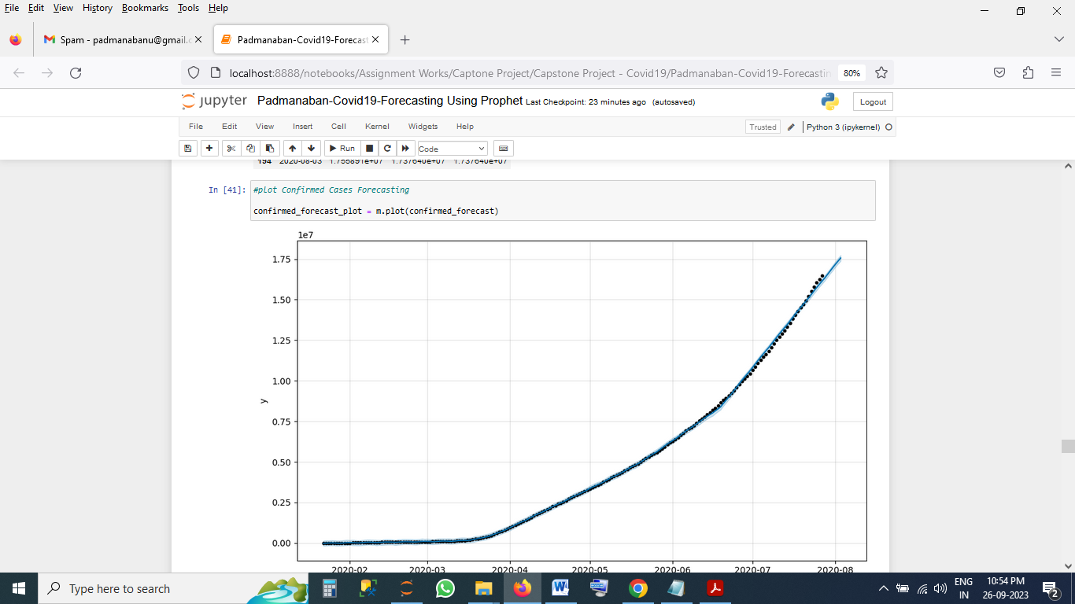

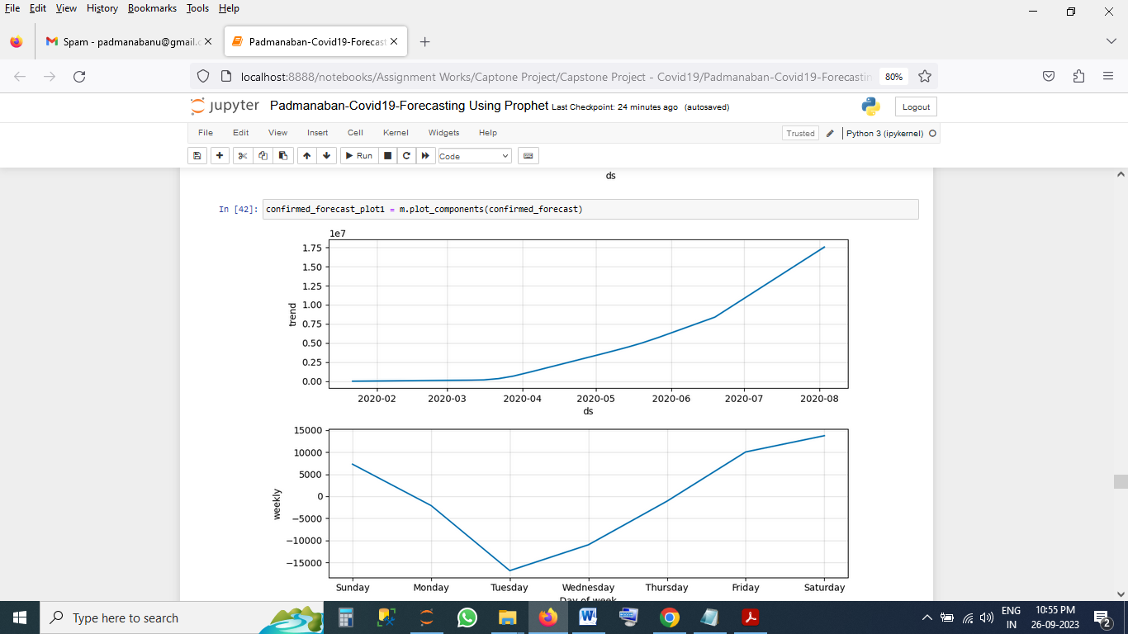

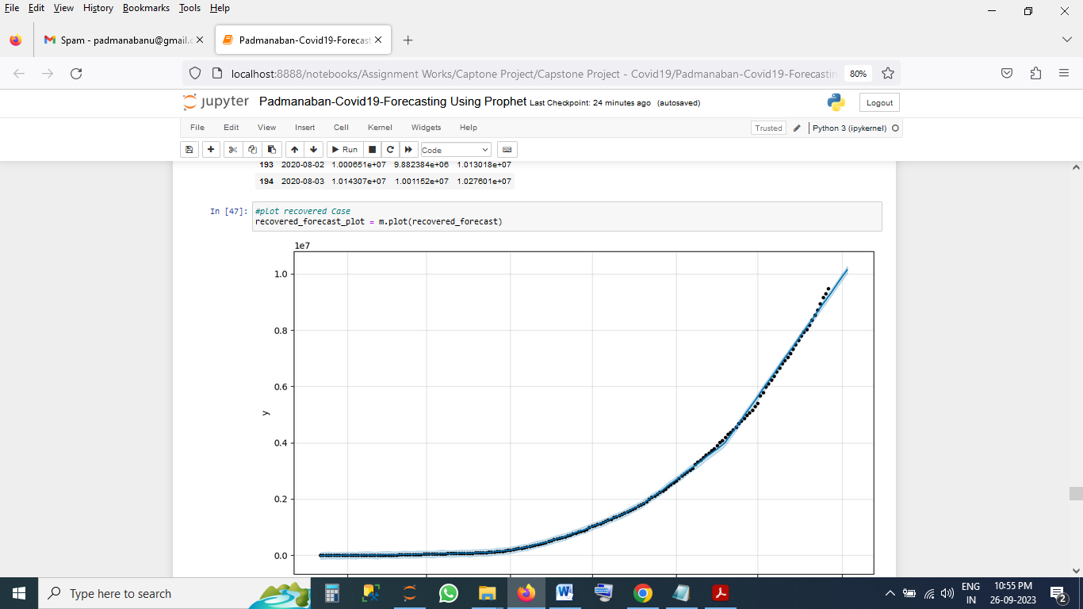



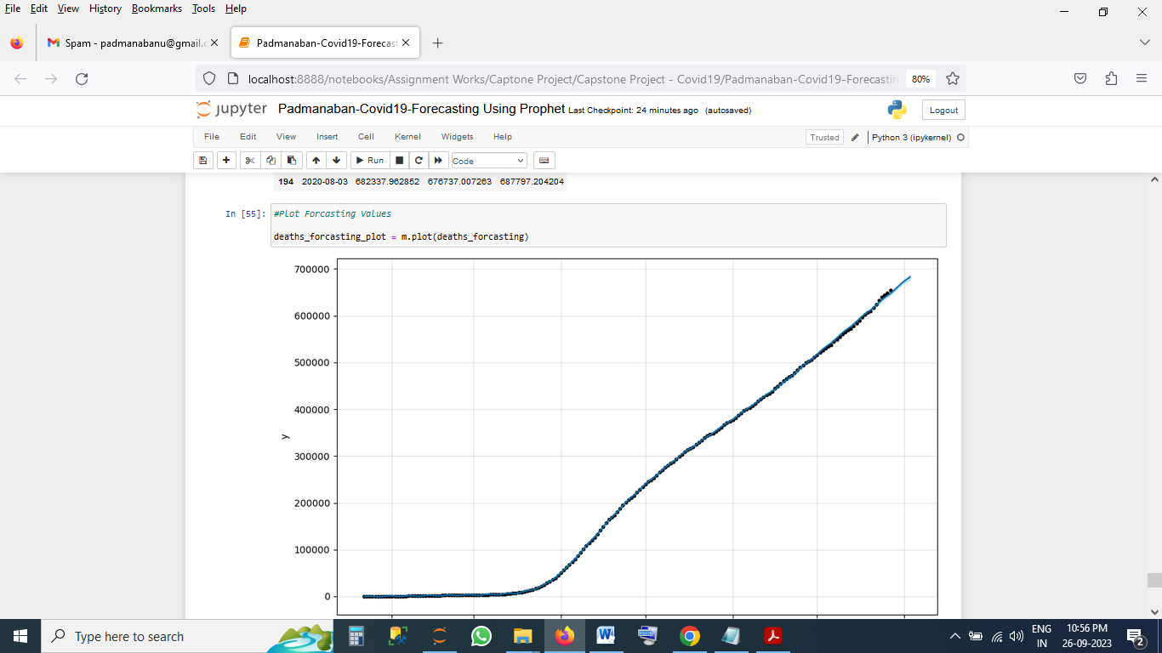

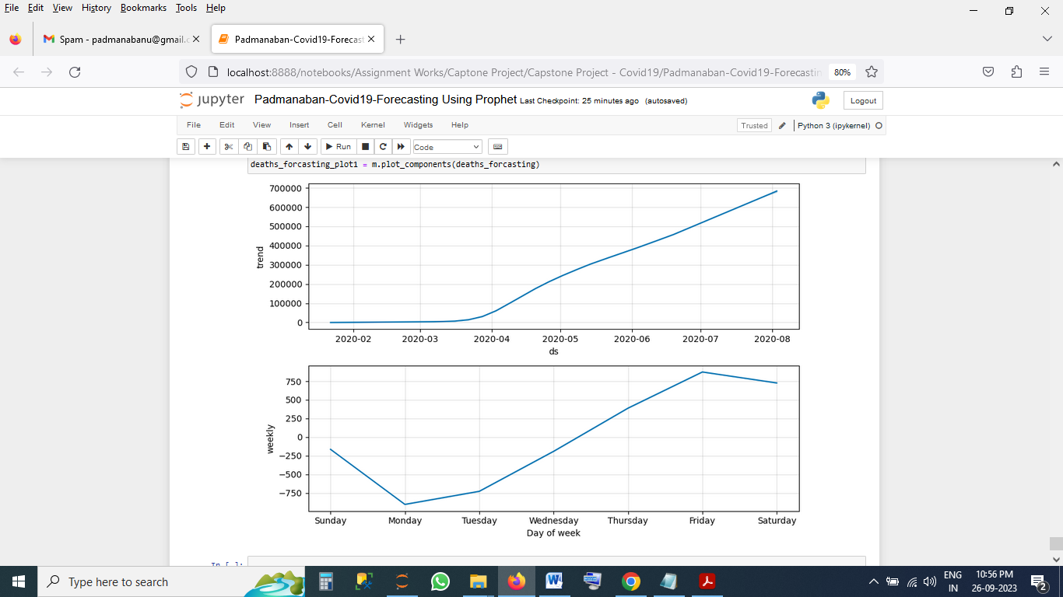

**8 Conclusion**

If Our Prophet forecasting Model Gives better Results

**9. References**

* Our Session Live Class (For Forecasting)
* Chat GPT
* Kaggle